**Problem: HttpContext controller ke bahar access nahi hota**

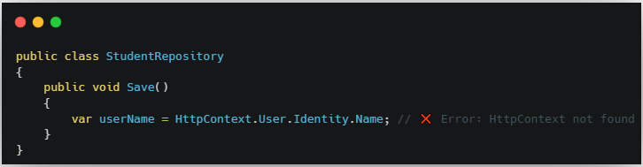

Yeh error dega kyunki HttpContext sirf controller me directly milta hai. Repository, service, ya helper class me nahi milta.

**🔹 Solution: IHttpContextAccessor**

1. **Startup ya Program.cs me register karo**



1. **Repository ya service me inject karo**

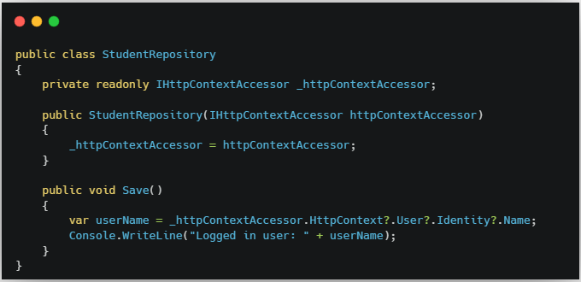

### 🔸 Summary:

|  |  |
| --- | --- |
| Direct HttpContext sirf controller me milta hai |  |

|  |  |
| --- | --- |
| Controller ke bahar chahiye to IHttpContextAccessor use karo |  |

|  |
| --- |
| AddHttpContextAccessor() se DI container me register hota hai |

### 🔹 ****HttpContext kya hai?****

HttpContext ASP.NET Core me **current HTTP request** aur **response** ka complete data store karta hai.  
Matlab: client ne kya bheja (request), aur server kya return karega (response) — sabka access iske through hota hai.

### 🔹 ****HttpContext me kya hota hai?****

| **Property** | **Use** |
| --- | --- |
| Request | User ka request data (URL, query string, headers, form data) |
| Response | Server se bheja gaya response (status code, body, headers) |
| User | Logged-in user ki identity (e.g. username, roles) |
| Session | User ke session data store karne ke liye |
| Items | Temporary data ek request ke dauraan share karne ke liye |
| Cookies | Client ke browser ke cookies read/write karne ke liye |
| Connection | Client IP, port etc. |